A primer on Chow-Lin Interpolation:

A recurrent problem in empirical macroeconomics is the desire to employ high frequency data when the researcher can only really depend on lower frequency one. For example, one would like to have an estimate of monthly GDP, yet GDP is only released once a quarter by the BEA.

One way of solving this issue is to take advantage of the relationship between those series released at lower frequencies and those released at higher ones. For example, one could use monthly data on consumption, industrial production and employment which are greatly correlated with GDP to infer what monthly GDP might have been.

A classic paper by Chow and Lin (1971) proposed a method for doing just this. In fact, under their assumptions, their method produces the best linear, unbiased estimate of the high-frequency data. Without loss of generality we will refer here to an interpolation between a quarterly time series to the monthly frequency. But the same approach could be used to interpolate an annual time series to the quarterly frequency and so on.

Assume that 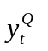is the quarterly times series that the researcher observes but would like to use at a higher (in this case monthly) frequency. We assume a relationship of the following type: 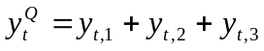, where 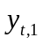denotes the series in the first month of the quarter and so on. In the month i of quarter t the researcher is, nonetheless, able to observe other variables which are assumed to be related to in the following manner:

and that
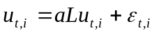

Where L denotes the monthly lag operator, which could be in the previous quarter and 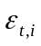is iid with mean zero and variance . Accordingly, the 3Tx3T variance-covariance matrix of monthly errors is:

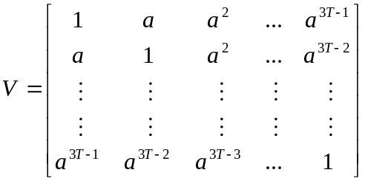

Let 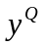and 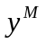denote the vectors of quarterly and monthly series of lengths T and 3T respectively. Then one could write 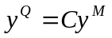where:

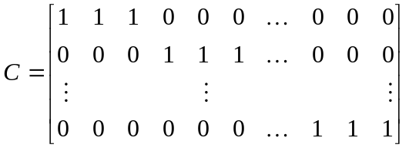

In that same fashion, we could form quarterly estimates with those series that are available to the researcher on a monthly frequency. As such, let 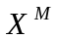be the 3TxP matrix of the monthly variables and define 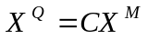. With this expression, we can write our original equation in the form 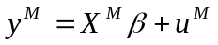and the premultiply this by C to yield:

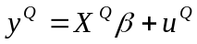

where 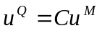. In this regression the variance-covariance matrix of errors is CVC’ and multiplying this out, the first autocorrelation of the errors can be calculated as:

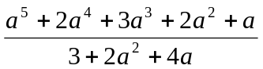

With all these building blocks, one could summarize the Chow-Lin interpolation procedure as follows:

First, construct the observed quarter series, from the observed monthly ones:

Second, obtain the OLS estimates from quarterly observed data:

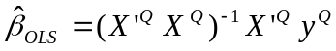

Next, calculate the first order autocorrelation of the residuals from this OLS regression and find the value of “a” that sets the value of CVC’ to this autocorrelation. With this value of a, obtain an estimate of V named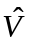. Given this estimate, obtain a FGLS estimate by:

Finally, obtain the corresponding residuals: 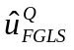and use this to obtain the monthly estimate. Chow and Lin show that this will be the best linear, unbiased estimator:

